Strategy 2015/16

www.thirdspacegawlay.ie

Contents
Section Page

1. Introduction and Summary 3
2. Mission and Values 5
3. Third Space Programme 2015/16 - 12/18 months 6
3.1 Cultural Hub: Venue 7
3.2 Arts in Context - Residency Programme 7
3.3 Artform Development: Research, Discourse and Practice 9
3.4 Website Forum & Archive 15
3.5 Audiences - Community Education and Outreach 16

Appendex 1. Member Biographies 18
Appendex 2. Proposed Guest Biographies & Case Studies 25
Appendex 3. Monica Flynn - Cafe Series 36
Appendex 4. Context – Local and National Development Strategies 38
Appendex 5. Key Achievements & Activities 2014 42

1. Introduction and Summary - www.thirdspacegalway.ie

Third Space is a Galway based, Interdisciplinary Arts Research initiative.

Serving as a locus within the community, Third Space Arts Collective aims to develop and deliver tangible local cultural benefits in partnership with diverse local communities and stakeholders and offer a contrast to traditional gallery practices by presenting and supporting community-based arts engagement in a centre for cultural exchange.

Aims:

- To bridge contemporary creative practice with other disciplines including community development.

- To create a curatorial and critical discursive platform for the exchange of ideas and trans-disciplinary working methodologies.

- Provide a network for artists, academic disciplines, key stakeholders and members of the community, including a Website Forum; that will act as an interface and conduit for local and global knowledge exchange.

- Identify local and national development supports necessary for collaborative, participative and community arts.

- Actively demonstrate the benefits for the cultural practitioner to be embedded in the local development context.

- Address the developmental needs of the community arts sector and liaise with partners in the delivery of a high quality education and outreach programme.

- Share research findings and opportunity nationally and internationally

How will this be achieved?

Third Space consists of a group of artists, academic researchers and community and cultural practitioners. We aim to build upon the rich resource of its members and develop a thought provoking programme of discursive events, community projects, residencies, film screenings and educational workshops throughout 2015/16.

The principal concept behind Third Space is that significant art proceeds from a discursive and critically reflexive culture. To date we have hosted a research group with the support of the Community Knowledge Initiative, NUIG exploring best practice in the theory, practice, development and delivery of Community Arts and initiated a transdisciplinary research project, Collaborative Ways Forward, with members from Transition Galway, P2P Foundation and An Ait Eile. Members have attended conferences, undertook research visits, and held and co-hosted arts and cultural events since 2013.

In addition, Third Space has devised a developmental plan to build the necessary structures of support for a community and collaborative arts platform for Galway City and County.

Objectives for 2015/16

- Develop a cultural hub, support and resource centre for community arts.

- Initiate Public and Cultural Discourse by inviting key thinkers and practitioners for interdisciplinary talks, workshops and programme development (for example, curating and cohosting Convergence 2015 and hosting a public trans disciplinary discursive forum with artist Monica Flynn; see Cafe Series appendix 3).

- Initiate an Open Call for a Galway Residency Project: a programme that supports artists to engage with place and community.

- Ongoing development of the Research Archive and Forum to contextualise and contribute to collaborative knowledge creation (we wish to work with Dr. Tara Byrne and Annie Fletcher to revisit the work of Cork Caucus, ‘Art, Possibility and Democracy’ NSF, EU Capital of Culture Project 2005, with a view to the development of 2020 project for Galway).

- Initiate a cross border and International Exchange Programme (we wish to work with WHW Curatorial Collective in Croatia, also designated EU Capital of Culture for 2020, & Ps2 Belfast on a cross border Peace and Reconciliation Project, AAA in Paris etc).

- Continued development of our website forum. Appoint a website forum moderator.

- Develop the role of Curator-Producer, enabling curatorial role in community contexts to work with artists and identify key partners, stakeholders and potential funders and collaborative opportunities.

2. Mission and Values

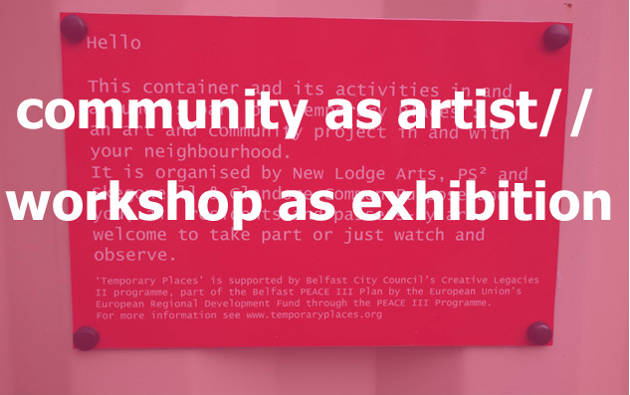
Ps2 Belfast – Open Call Nov. 2014

Third Space Mission:

• Support creativity, innovation and excellence in the production, practice, presentation and discourse of contemporary collaborative and community arts

• Increase public access, awareness and engagement in the arts by providing people with greater opportunity to experience and participation in the arts

• Foster and promote contemporary arts engagement within the wider socio-cultural contexts of place and community

Our Guiding Values:

• Believe art can and does make a difference and play a significant role in the quality of life

• Believe people everywhere have a right to culture and access arts activity

• Believe in working in innovative ways for creative practice to be accessible, inclusive and participatory

• Value sustainable partnerships locally, nationally and internationally

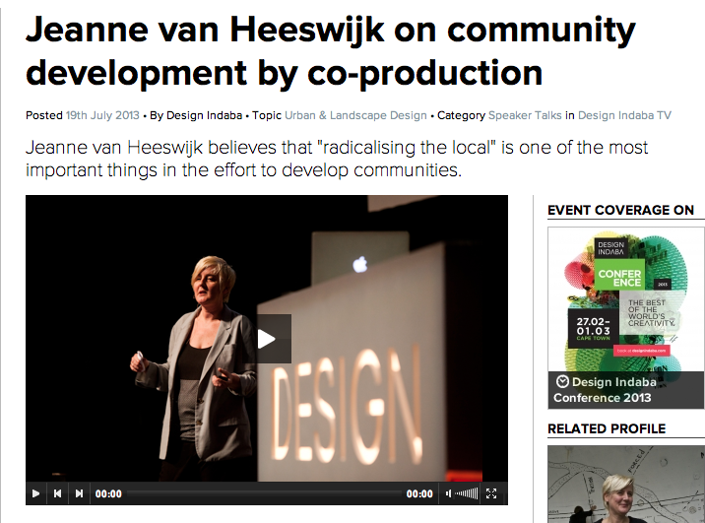

3) Third Space Programme 2015/16 – 12 /18 month

3.1 Venue – Public Project – Library, Residency & Community Workshop

“Venues provide a solid infrastructure of critical importance for the arts nationally. As focal points for arts activities, they help communities to develop a voice and they provide opportunities for investment in the creative energies and skills of future generations” Arts Council

To expand the work of Third Space Arts Research Collective, build on research findings to date, and address some of the recommendations of the Creative Communities Report 2013, undertaken by CKI; Community Knowledge Initiative NUIG, GCCF; Galway City Community Forum, and GALCA; Galway Community Arts Association, which identified the need for a central resource space and educational supports for community arts practices. Third Space aims to address a number of the identified needs and work with Galway City Council in creating a space for the promotion and development of collaborative and social engaged arts practice in Galway City and County. http://cki.nuigalway.ie/organisation/view/256

Our vision is of a community with creativity at its heart. A community culture in which artists work and local people are offered the opportunity to engage with the arts in their own territory and on their own terms.

The project proposes to establish a centralised residency programme, workshop, action research site and library to house and curate local community arts, cultural research and activity. Our initial aims are to concentrate on building relationships with local community groups in order to respond to local needs, seeking to develop a way of working that both engages with the community and supports artists with an interest in locating their practice in that community. The aim is to test out innovative and creative methodologies and processes that include setting up community based residencies, delivering arts training and exploring capacity building among youth leaders and community workers as well as providing ongoing professional development and mentoring opportunities for artists in partnership with local and national professional development bodies such as Visual Artists Ireland and Create.

Third Space aims to build upon existing partnerships and identify new partners to collaborate with in the city and county such as the City and County Councils, ECoC. Arts Council, CKI /NUI Galway, NUIG, GMIT, GTI, GCCF/ PPN, GALCA, VEC, ADAPT, CREATE, VAI, Bluedrum, Solas, Galway & Roscommon ETB (VEC), HSE, Galway Arts Festival, Gawlay Arts Centre, Foroige, Transition Galway

3.2 ARTS IN CONTEXT – Galway Residencies - Proposal for Participative and Collaborative Arts Practices 2015

Third Space’s objective is to foster and cultivate a deeper awareness of art in relation to all aspects of contemporary life and culture by running a thought-provoking programme of events, projects and residencies that develops the contemporary arts in new directions in Galway City and County.

Acknowledging the current European Capital of Culture (ECoC) bid as a timely opportunity for Galway City and County to celebrate and showcase the uniqueness of its culture, creativity, people and place, Third Space, offers to engage with this process as a catalyst in providing for the development of a high-quality grassroots, community and socially engaged arts and cultural residency project, allowing us to facilitate our designation as a European Capital of Culture, while have greatest impact for Galway and its communities.

Galway City is currently served in contemporary art gallery practices and local Festivals, however there is no platform in Galway in a position, with the specialist knowledge and supports required, to engage in the increasingly prolific field of socially engaged arts and cultural practices, as is currently been developed by Third Space. This research and residency project proposes to develop a model for a new kind of socially engaged art and residency programme for Galway, which works beyond the established structures of the art context, and that aims to rework the idea of culture against the backdrop of emerging issues, providing artists with the opportunity to realise their projects using the social, cultural, academic and economic networks of the local area.

Offering new approaches to artistic process, production and exhibition, and creating a locus for contemporary art and cultural activity, being flexible and multidisciplinary, the Third Space project, in contrast to traditional institutions, museums and gallery practices, may not use typical exhibition space, but rather provide artists with the opportunity to realise projects using the social, cultural heritage, academic and economic networks of the area and beyond, with the aim to work in multiple locations, to be part of a network of ideas and activity, connecting local and global conditions, in a responsive and appropriate way.

This expanded field of activity currently goes by a variety of names: socially engaged art, community-based art, experimental communities, participatory, research-based, and collaborative or community art and seen as complex, multifaceted and context-based; whereby artists and arts collectives have develop innovative projects that are concerned with the creation of work and arts practice outside of the mainstream galleries and museum spaces and within diverse public or community contexts. These practices are interested in the creative rewards and social and political transformative potential of collaborative activity. The Arts Council understands participatory arts to include a broad range of practice where people collaborate with skilled artists to make or interpret art in which the core purpose of this work is to develop creative individuals and communities.

The Third Space programme aims to actively engage with the complexities of the local area, rather than aiming to create a finished art product it places an emphasis on process and the dissemination of ideas to a wider audience, that allows public access to the arts process, introduces artists’ thinking into everyday life and sites active contemporary arts alongside the culture of the local environment. Artists are invited to work on community projects, the principle aim being to generate and disseminate new ideas and approaches to how the work may be used. The activities can be fed into a major annual local project and/or existing Galway City/ County Arts events.

Objectives:

•Develop research and development residencies, awarded to artists
and creative practitioners, local national and international, to develop ideas for projects in relation to the extraordinary socio-cultural environment of Galway
•There is no fixed period for each residency, the preference being for artists to establish a long- term relationship, whilst they continue normal practice.
•Artists are invited to work on projects in a specific local context, the principle aim being to generate and disseminate new ideas and approaches to how the residency may be used
•Creating a constructive role for art and artists in a time of immense cultural change, both locally and internationally.

Third Space proposes in association with Galway City and County Council Arts Offices and the ECoC programme, to offer five residencies to visual artists in 2015/16. Each residency has a total value of €4,500 and includes all costs attached to the residency. Background of artists applying for these residencies: While subject to alteration, in the allocation of residencies, it is envisaged that:
· Up to two residencies will be for artists originally from or living in area
· Up to two residencies will be for artists from elsewhere within Ireland.
· and Two residencies will be considered for an artist from outside Ireland.

The Galway Residencies proposes ‘Residencies to support artists to lead engagement with places / people / industry / groups / communities or landscapes …(to be suggested or identified by the artist in their proposal or in response to potential local partners ).

Curator/ Producer Role
Role of Curator in commissioning is recognised as supporting, co producing and overseeing negotiation and artistic vision, from the concept to the completion of project. As well as working with various partners and stakeholders involved, the Curator will have a role in accessing and identifying new potential in funders/ partners and develop and negotiating working relationship throughout the commissioning process, identifying clear roles and responsibilities.

The Evaluation –
Will be integral to process, and embedded from the beginning, providing productive suggestions as a qualitative tool and not a pre-emptive checklist and will benefit from and feed into Third Space programme of ongoing documentation and evaluation of evidence based Research in this field of practice.

3.3 Public Discourse – Building Galway’s Cultural Capital & Conversation

Third Space fosters a belief that a vibrant public discourse and international exchange of ideas is vital in the city’s cultural development and proposes to stimulate the local socio-cultural environment by establishing a critical, thought provoking platform that actively explores the intersection of art and society, through contemporary discourse. Aiming to provide a platform for development of local artistic culture and concerned with addressing questions, similar to those of EU Capital of Culture Cork Caucus in 2005 – ‘How artists, cultural workers, diverse disciplines and a local community can come together, to explore and give rise to new creative methodologies of engagement in the development of academic, cultural and democratic processes?

Third Space proposes to invite and work with former Director of Cork NSF, Tara Byrne and Curator Annie Fletcher and develop a discussion with them re the development of a new iteration, ten years on, of the highly successful project - Cork Caucus, Art, Possibility and Democracy that took place as part of Cork Capital of Culture 2005, developing a Galway based response and initiating research of Cork Caucus Publication by Third Space Research Forum– generating further discussion and artist and community engagement for 2020

Cork Caucus, Arts, Possibility and Democracy – 2005
Cork Caucus was a significant trans-disciplinary meeting of artists, writers and philosophers that took place from June 20th July 11th 2005 in Cork City, Ireland. The purpose of Cork Caucus was to use the city as a base to investigate the relationship between art and the possibility of social change in a specific place. Through a range of activities, Cork Caucus aimed to provide ways in which the ambition of art to intervene in social life and political thinking could be debated.
http://www.e-flux.com/announcements/cork-caucus-june-20th-–-july-11th-2005/

To initiate a cross disciplinary discursive public arena, Third Space, proposes to work with artist Monica Flynn, to further develop her Café Society series of Cultural Conversations and open up discussions in this area within and relevant to the local Galway Context.
Please see Appendex 3 ‘Café Society’ Programme by Monica Flynn.

‘The history of cafés sparked a lot of ideas as public spaces where artists, writers and philosophers gathered. The café struck me as a sort of in between space – neither work nor home – where commerce, publicness and cultural debate intersect. The primary aim was to test the appetite for public debate, inviting speakers from academia, the media and the arts… I was conscious of the rhetoric around 'creativity' which renders cultural production as economic commodity rather than something generated by the collective efforts of citizens. Pragmatically, I was concerned with ideas around active citizenship and the diminishing spaces for public debate.” Monica Flynn

Artform and Professional Development Supports

Third Space research sessions aimed to address and explore histories, theories and practices associated with socially and politically engaged art practices and art in the public realm – Introducing historical and contemporary approaches to the public sphere (through the writings, for example of Jacques Ranciere, Hardt and Negri, Jurgen Habermas and Chantal Mouffe) It also aimed to engage with current theoretical positions on participative and collaborative practices (Nicholas Bourriaud, Claire Bishop, Field, - an online journal, Tania Bruguera’s Association de Arte Util) and intersects with critical debates about working in and with communities (Grant Kester, Jeanne Van Heeswijk and Jean-Luc Nancy, Martha Rosler, Deirdre O Mahony etc) as well as exploring new trajectories of inquiry and practice with other fields of knowledge production, from urbanism to environmentalism, from experimental education to participatory design… and aims to be relevant to architects, artists, activists, curators, cultural workers, educators, sociologists, geographers and local community members, visitors and residents.

The Third Space Research Collective aims to act as an ongoing interface and conduit for information between the ongoing developments in the field of social practice globally and locally - and also engage with other international platforms working in this area. For example the P2P Foundation, Homebaked, Liverpool, Paris based Autogeree Atelier Architecture etc, and as part of building an ECoC project, we wish to work with artists from Croatia, as fellow European Capital of Culture Capital holders in 2020. Third Space proposed to initiate an international exchange with Curatorial Collective ‘What How Whom’, from the State run, Gallery Nova in Zagreb, to co curate and develop an international arts exchange. http://www.whw.hr/novosti/index.html

Third Space has also initiated contact with International Arts Platform PS2 in Belfast, as part of their current curatorial programme ‘Community as Artist – Workshop as Exhibition’ and wish to collaborate on a cross border Peace and Reconciliation Project and develop a proposal working with Seoidin O Sullivan’s Seating System as a site for ‘commoning’ and of ‘empowerment and possibility’ and to seek funding to generate an international collaborative and participatory platform in 2015. http://www.pssquared.org/community_as_artist.php

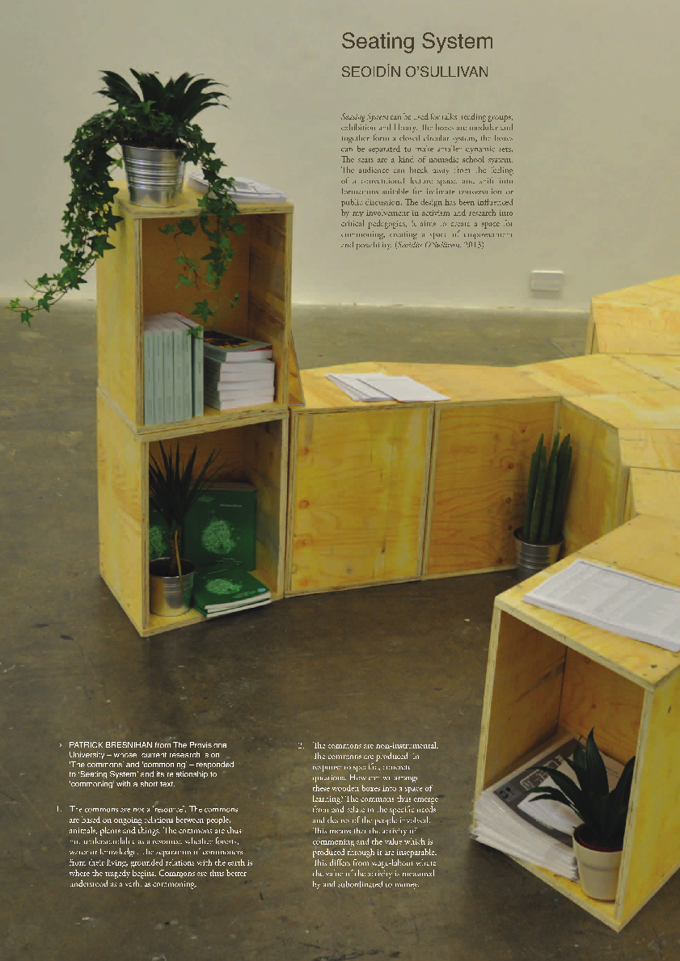

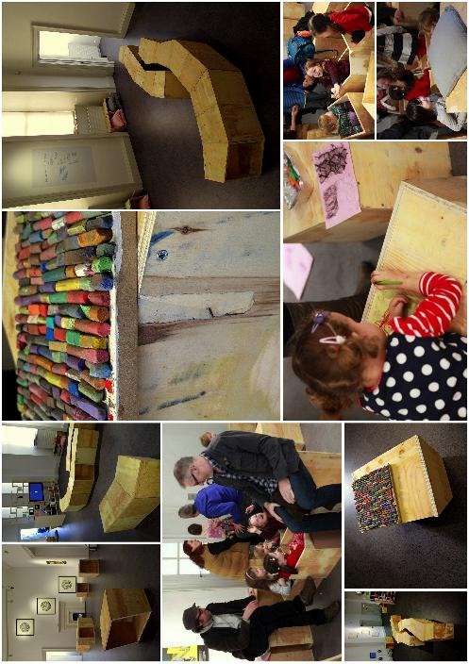

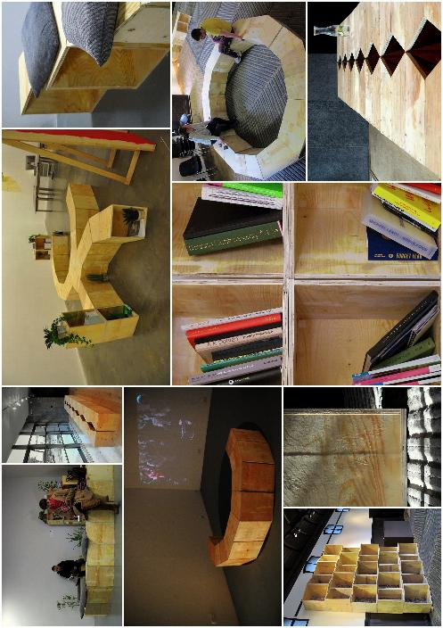

3.4 THIRD SPACE WEBSITE & FORUM

LINK: http://thirdspacegalway.ie/

The Third Space website hosts an archive of events, dialogues and diverse forms of public engagement, research and case studies in the fields of participatory and social engaged practice undertaken by the Third Space Arts Research Collective todate.

The Research Archive is part of the ongoing artist’s research-led initiative to contribute to the provision of specialist and contextual knowledge and discourse on contemporary cultural practice with a particular emphasis on interdisciplinary, collaborative, participatory and social practice.

Our purpose is to develop further a research and participative forum exploring creative strategies, practice and the (changing) role of the artist/art in times of transition, both within and without the institution, concerned with the questions raised about the role of art itself, as it engages with other disciplines and other modes of cultural production, by inviting practitioners to contribute through a moderated online debate, discussion and interaction, as well as hosting and commissioning relevant interviews, reports and research papers in this growing field of arts and cultural practice.

This online research forum aims to act as an interface and conduit for information between the ongoing developments in this field of practice globally and locally - and engage with other international online platforms working in this way.

3.5 COMMUNITY EDUCATION AND OUTREACH

Cultural Education, Outreach and Audience Development
Definition of Community Education:

“Community Education is education and learning which is rooted in a process of employment, social justice, change, challenge, respect and collective consciousness. It is within the community and of the community, reflecting the developing needs of individuals and their locale. It builds the capacity of local communities to engage in developing responses to educational and structural disadvantage and to take part in decision-making and policy formation within the community. It is distinct from general adult education provision, due to both its ethos and to the methodologies it employs”*.
Aontas, 2004, p18.
‘Understanding the arts as an integral part of culture – inclusion of community led initiatives and facilitating accessibility to the arts, addressing the argument that people have a right of accessibility to the arts as identified in the UN Charter on Human Rights. UNESCO have captured the importance of cultural heritage and highlight ‘This intangible Cultural Heritage, transmitted from generation to generation, is constantly recreated by communities and groups in response to their environment, their interaction with nature and their history and provides then with a sense of identify and continuity’
The Third Space objectives include taking action to enable people to participate in cultural life, to experience culture and to engage in creative activities of their own; enabling culture to act as a dynamic, challenging and independent force; promoting cultural and interdisciplinary exchange and meetings between different cultures; safeguarding freedom of expression and creating genuine opportunity for engagement.
Third Space’s core aim is to promote access, appreciation, awareness and enjoyment of the arts for the communities of Galway and beyond and is committed to audience development and wide ranging community participation and engagement in partnership with existing bodies and stakeholders such as GCC, ETB (VEC), Bluedrum, CREATE, VAI, GMIT, NUIG, etc and in targeted and expanding the potential and possibilities in the reach of existing annual cultural events such as Culture Night, Galway Arts Festival, Tulca etc
It aims to undertake establishing strategic partnerships with key stakeholders and delivering a diversity of educational events, workshops and community outreach programmes, and by offering a series of workshops and opportunities that encourage expanded participation and arts engagement.
The aim is to coordinate a series of events and educational workshops throughout the year, both onsite, but also with a good geographical spread and reach to areas and communities around the city and in various venues libraries and non arts venues, such as family resource and community centres, and engage with the widest possible audience and the widest possible age range. Our programme aims to widen the cultural activities on offer to people in the area, and aim for city wide engagement from the communities living in the outlining areas.
The arts play an integral role in the life of Galway City and County. From local community groups to micro-enterprises, from solo practitioners to the nationally and internationally renown organisations, Galway has a long history of cultivating and showcasing the arts. Seen as a vibrant city of culture a high percentage of the population is said to be currently engaged in work in the arts sector such as theatre, literature, arts, crafts and design. However many reports show that there are also many marginal groups, people and communities excluded.
Third Space Community, Education and Outreach programme aims to improve access, appreciation and understanding of participatory and socially engaged arts practices and processes, by providing education and training, to a wide range of people, facilitated by our members but also from those to the fore in their professional practice nationally and internationally in association with various local and national cultural partners.
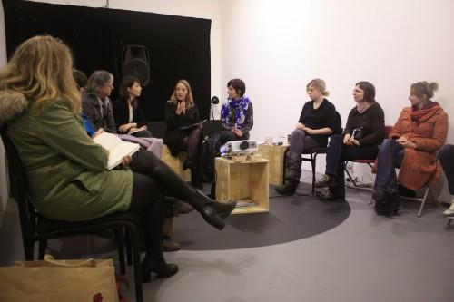

APPENDIX 1. THIRD SPACE MEMBER BIOGRAPHIES

Nuala Ní Fhlathúin

Nuala Ní Fhlathúin is from the Gaeltacht area in the West of Ireland. She received a BFA in Ceramics from GMIT, Galway, and an MFA in Sculpture from the University of Washington, Seattle. Her work has been exhibited in Ireland, the USA, Portugal and Georgia. She is currently a member of Engage Studios in Galway. In addition to her art practice she edits Nua-Ealaín, an Irish language website for the contemporary visual arts.
Recent Shows include Tulca 2013, Aras Eanna, Inis Oirr, Belfast, 2014

Michaele Cutaya

Michaële Cutaya is a writer on art and lives in Galway.
She contributes to Irish art publications printed and online: Billion, Circa, Critical Bastards, Enclave Review, The Irish Arts Review, Shower of Kunst, The Visual Artists News Sheet. She Co-founded Fugitive Papers.

http://michaelecutaya.wordpress.com/
http://www.fugitivepapers.org

Amantine Dahan

Amantine Dahan is a visual artist with an MFA (NCAD) and holds an honours degree in Art & Design in Sculpture (GMIT). Since graduating in 2007 Amantine has worked primarily with lens based media, documentary photography, video installations, and video performance. In her work, she attempts to explore the relationship with oneself and others; How one comes to himself in relation to the world as one ‘s sense of self is the element in which I, You, We, take place. Emmanuelle Levinas poses the relation between oneself and other as alterity and otherness, exposing the pathos of an essential incommunicability. I am interested in the overlap of these two apparently opposite strands of thought referencing ethical, historical and social contexts and how they correlate. Recordings and texts have been the bridge to her socially engaged practice, she has been part of ‘Burning Bright’ since the beginning of the project. She has had much experience as a workshop facilitator having worked in many resource centers in Galway, primary and secondary schools and in the Galway Art Center. Lately, she has developed this module “The Stitch” using embroidery, textiles and story telling.

Katherine Waugh

Katherine Waugh is a curator, writer and filmmaker based in Galway.
She is currently co- curating Schizo- Culture – Cracks in the Streets at Space Studios, London. A project taking the seminal 1975 event Schizo-Culture: On Prisons and Madness as its point of departure. She co-directed The Art of Time, a film on the complex temporalities in contemporary art, film and architecture, which has shown internationally in galleries and Film Festivals in New York, Paris, London and most recently in IMMA and Dublin City Gallery The Hugh Lane as part of Sleepwalkers. She is a founding director of the experimental film festival Different Directions Film Festival in Galway.

In 2012 she curated and moderated a symposium for the AV International Arts Festival in Newcastle based on its theme As Slow As Possible (after John Cage) and programmed a series of films for IMMA where she also gave a talk on Time in Contemporary Art and Film. She has written essays for artists’ books and catalogues nationally and internationally, and a recent film installation project – A Laboratory of Perpetual Flux – was shown as part of eva International curated by Annie Fletcher. She has recently completed her curatorial research with Goldsmiths College London.

Dr. Anna King
Ph.D, M.A. B.A.

Writer specialising in performance ethnography & arts-based research methods that value the centrality of culture in local, regional and European policy-making.

Anna King is developing a unique Irish methodology for understanding the palette of complex ways in which local communities cope and respond to changing social and cultural landscapes. Apart from elevating the role of public places in the community-building puzzle, her current research links aesthetic and social theory with arts-based community research methods. It show cases a unique intercultural comparative Irish case study that will provide a socio-cultural development model that is responsive to the needs of multiple actors, thus providing a platform from which to engage critically with local, national and European policy

http://publicspaceperformance.com/index.html

Padraig Conway

Padraig Conway has exhibited in Galway (‘Solas Atlantas’ Galway Arts Festival, 1994. ‘Dunkellins Plinth’ Eyre Square, 2008), nationally and in the USA. In addition to experience abroad with fine art studios and commercial printmakers, holds Design and Media Technology certification. A First Class Honors Degree in Fine Art (Printmaking). The ‘Norman Ackroyd Etching Award’ and a Masters Degree in Fine Art. The paper, ‘Online’ has been Highly Commended in the Visual Arts category of The Undergraduate Awards 2014

Jane Queally

Jane Queally completed an MA in Visual Art Practice from IADT 2012 and a BA in Fine Art ( Hons ) from Sligo Institute of Technology 2002..
She works predominately in painting and experimental photographic media, the latter is concerned with analysing representations of the photographic image in print media as ‘document’, in a social context.
She has exhibited in several solo and group exhibitions, including the Claremorris Open 2011/12/14. ‘Public Gesture’ The Lab, Foley St, Dublin 2011. G126 Annual members show 2012/14. Upcoming 2015 ‘Teling Lies’ Rua Red Tallagh curated by Paul Mc Aree. She has been the recipient of Visual Art Bursary awards from Galway City and county councils and the D O’Sullivan Graphic Medal from the Sligo Institute of Technology. Her work is in a number of public and private collections including H.E.T.A.C Dublin, Aras an Uachtarain and S.I.T.

Ceara Conway

Ceara Conway is an artist and singer from the Connemara Gaeltacht in the west of Ireland.
Her artistic practice has taken her all over the world, from glass blowing in Italy to silent meditation retreats in India and assisting the artist Suzanne Lacy on her reproduction of ''Three Weeks in January, End Rape in LA''.
Since 2001 she has been commissioned to create an extensive number of large scale public art commissions nationally and internationally including ''Vicissitudes" (2013) commissioned by 'Difference Exchange' and the Derry City of Culture and her most recent work ''Making Visible" (2013- 14) supported by the Irish Arts Council managed by CREATE.

Ceara's practice utilises a wide range of materials and approaches including sculpture, photography, performance and song to produce multi disciplinary, site specific and issue specific works. She has developed a social and personable approach gathering knowledge and experiences from collaborators in which she combines with her own observations to create works that are beautifully reflective and poetic. She has received several Awards and Bursaries from the Arts Council, Ealain na Gaeltachta and County/City Arts Offices. In 2012 received a Paul Brady Scholarship from the World Academy of Music University of Limerick.4

Her most recent 2014 works include. A residency with Taigh Chearsabhagh Museum/Atlas Arts Commissioned by Broad Reach: An ATLAS; Solo Performance for the National Gallery of Ireland for their 150th Anniversary Event.
www.cearaconway.com

Ann Lyons

Ann Lyons is the co-ordinator of EPIC – Engaging People in Communities at the Community Knowledge Initiative, NUI Galway, Ireland. EPIC works in close liaison with a wide range of individuals and groups, both inside and outside the university, to further community-university links and partnerships, with particular emphasis on community-based research and knowledge sharing and exchange. From 2008 until 2010 she was the co-ordinator of Campus Engage, a higher education civic engagement network, funded under the Irish Higher Education Authority’s (HEA) Strategic Innovation Fund (SIF), to develop and support civic engagement activities in higher education in Ireland. She is joint editor of Higher Education and Civic Engagement: Comparative Perspectives, (2012), Palgrave Macmillan; joint author of Survey of Civic Engagement Activities in Higher Education Activities in Higher Education in Ireland, (2011), (Campus Engage) and joint editor of Mapping Civic Engagement within Higher Education in Ireland, (2009), (AISHE & Campus Engage).

Martina Finn

Martina Finn, established the Third Space Interdisciplinary Research Collective as part of her M.A. in Visual Arts Practices, (MAVIS) IADT, Dun Laoghaire, completed in 2014. She holds a BA in Social Science (1989) Post Graduate Dip. in Multimedia Communication and Development Studies (1999) Higher Diploma in Arts Policy and Practice (2005), FETAC Art & Design (2005)

Reflecting work experience in a variety of arts, community and cultural contexts, she is currently developing a curatorial practice and inquiry into interdisciplinary creative practice and aesthetics that responds to and addresses specific socio-political and cultural contexts. She is interested in generating situations for active information exchange and collaborative trans- disciplinary knowledge production as key dynamics in artistic and cultural practice. Her work actively questions and explores the relationships between cultural agency, critical practice and collective and activist strategies.

As a curator, she is interested in contemporary art and curatorial practice that is based on ideas from the discourse of art, which include the capacity for thinking critically and creatively across disciplinary boundaries, raising key questions and examining the relationships around the interdisciplinary fields of cultural production and between the arts and their critical and socio-cultural contexts.

Areas of research and curatorial interest reflect work experience to-date which include: Community and Public Art Projects, Arts and Cultural Heritage Management, Community Development and County Council Arts and Community Development Officer

Úna Spain

Úna Spain is a visual artist with a research Masters Degree in Contemporary Art practice and Media (LSAD). She holds a Diploma (with distinction) in Art & Design from GMIT and also an Honours Degree in Photography from DIT. Since graduating from DIT Úna has works primarily with lens based media and her work continues to receive positive critical acclaim and attracts curatorial attention. She has engaged with numerous community and voluntary arts based projects over the last decade and also has experience teaching from pre-school level to third level.

Zeneb Maghrebi’s (aka Betsy Carreyette)

Zeneb Maghrebi’s (aka Betsy Carreyette), practice-led research The Fine Line, is an ongoing body of work positioned on the contested line between the making of traditional pottery and the unremitting expectations of tourist-led development in and around Siwa Oasis, Western Desert of Egypt.
She is the founder of upcoming residency programme, Agben ga Adrar Netlakt, ( House at Clay Mountain), in Siwa Oasis. The practitioner is commencing doctorate research at University of Sunderland, UK, Autumn 2014, where she aims to transpose crucial culturally-engaged discourse into the heart of contemporary ceramic practice.
Zeneb lives between West of Ireland and Siwa Oasis, Egypt.
http://www.zenebmaghrebi.com/
http://wheretheflamestillburns.blogspot.ie/p/siwa.html

Ruth McHugh

Ruth McHugh originally graduated from NCAD with a degree in Fine Art Painting. On completion and she was appointed Administrator of SADE 87(Sculpture and Drawing Exhibition). In 1987 she was a founding member of Artspace Studios where she acted as exhibitions officer from 1987 until 1994. In 1994 she was awarded a residential studio at the Firestation Artists Studios and was employed at the Artists Association of Ireland and The Irish Film and Television Academy.

From 1997 to 2007 she worked in various capacities at the Royal Hibernian Academy. This was an extraordinary period at the Academy with the new director Patrick Murphy. The works of major international artists Bruce Nauman, James Coleman, Michael Borremans, Felix Gonzalez Torres, Gerhardt Richter, Marlene Dumas, Toba Khedoori, Bill Viola, William Kentridge, John Gerrard amongst others were exhibited and Futures provided a new platform for emerging, contemporary Irish artists. McHugh simultaneously took on the role of Administrator at the Hallward Gallery as well as facilitating workshops for adults and children at the National Gallery and the RHA.

In 2006 she undertook a Masters Degree in Public Culture at IADT for which she investigated the Art Fair as Public Culture. She subsequently undertook a research Masters Degree at IADT in 2012, on the subject of Visual Arts Development and Cultural Tourism: The Case of Leitrim. Throughout this period she has developed her own practice (sculpture, painting, photography) a high point being the selection by Aidan Dunne to exhibit in an exhibition of Irish Artists Other Visions (2006) at Purdy Hicks Gallery in London. She exhibits with the Peppercanister Gallery in Dublin and has had numerous solo exhibitions including the Galway Arts Festival.

Evelyn Glynn

Evelyn Glynn has a degree in fine art printmaking and an MA from Limerick School of Art and Design (LSAD). She holds an MA in Community Development from NUI, Galway (1992). Her background in community development and her work in the area of violence against women alongside her studies at LSAD combined to produce the research project on the Magdalene Laundry. Her BA thesis ‘Left Holding the Baby: Remembering and Forgetting the Magdalene Laundry’ was the motivation behind her most recent project Breaking The Rule of Silence

http://www.magdalenelaundrylimerick.com

Trish O Flynn

Trish O Flynn completed her MA in Public Advocacy and Activism in the Huston Film School, NUIG 2012 and is currently undertaking a PHD with Teagasc on Creativity and innovation in Irish Farming. (Teagasc is the agriculture and food development authority in Ireland. Its mission is to support science-based innovation in the agri-food sector and the broader bioeconomy that will underpin profitability, competitiveness and sustainability.)

Bernadette Divilly

Bernadette Divilly is a Choreographer, Dance Movement Therapist & Dancer with an MA in Somatic Psychology & Dance Movement Therapy. She has an extensive background in Health Education and Dance. Specialisations include: Socially Engaged Choreography, Contemplative Dance, Dance Movement Therapy, Somatic Psychology, Humanistic Integrative Psychotherapy.
Bernadette has been recognised by IACAT with a Certificate of Achievement for pioneering Dance Movement Therapy in Ireland.Witness Me Walk was published in the Journal of the Irish Association of Creative Arts Therapists 2013.

Bernadette has spent time at the Naropa University exploring choreographic composition with Prof. Barbara Dilley whose teaching emphasizes “embodied awareness” through dance/movement studies, creative compositional processes and the disciplines of meditation. Another area of current investigation is Public Shaming and Institutionalised abuse, reversing shame and reclaiming the intelligence of the body through public art making.

In collaboration with film maker Dr. Maria Gibbons, Bernadette has recently made a short video on urban design and pedestrian experience in Woodquay and is currently developing “Walking Wisdom Woodquay”, an Arts Participation Project which is supported by The Arts Council and the Galway City Council Architect Office.
Bernadettedivilly.com

Elodie Rein

Elodie Rein graduated from GMIT in 2013 with a first class honours in Fine Art and is currently undertaking her Higher Diploma. In 2012 she received the GMIT CCMA Student of the Year Award. Her paintings are highly processed based and take the form of ‘Abstract Improvisations’ that often tease the boundaries of sculpture.
She has been selected to exhibit in shows such as the RDS Student Award, Dublin and Resonance, Galway. Her practice is multidisciplinary, including photography, contemporary dance and is very much informed by Yoga. She has participated in performances like Riot choreography as part as Galway Dance Day 2014, and Shed, a Butoh performance. She is involved in socially engaged collaborative projects in Galway.

APPENDEX 2 - Proposed GUEST /ARTISTS / MENTORS - BIOGRAPHIES

Third Space
Guests | Artists | Curators | Mentors | Advisors | Case Studies of Best Practice

Third Space aims to (co) curate a series of trans disciplinary arts and cultural talks, events and activities... in partnership with other key local, national and international stakeholders. Third Space aims to encourage debate on the role of the arts in civil society and curate public talks and lectures designed to further critical thinking in the field, and raise the profile and understanding of collaborative and community arts as a dynamic contemporary arts practice.

Third Space intends to reflect upon these processes by drawing on academic, visual culture, political and community art discourse and analysis to expand and critically contribute to theoretical debates within socially engaged art practices in Ireland and internationally

Proposed Guest/ Advisor Contributors include…

Monica Flynn – Biography

A visual artist based in Dublin, Monica holds an M.A. in Visual Arts Practices from Dun Laoghaire Institute of Art, Design & Technology, Dublin (2008) and a H.Diploma in Arts & Cultural Management from University College Dublin (2000). Her work in cultural management has focused on arts education and more recently continuing professional development for visual artists.
Following her MA in 2008 she co-founded The Market Studios, Dublin with curators Claire Behan and Deirdre Morrissey and worked as co-director of the studios for three years and now continue to contribute as a board member.

Her studio work employs a range of media including: choreo-graphed events; text; archive; drawing; video; audio and installation. The initial impetus for her work comes from theoretical and literary subject matter dealing with issues such as intersubjectivity, psychology and politics.

In Summer 2014 she completed an Artist in the Community Scheme project 'Hospitality' with Open Circle Community Arts Collective in Kilkenny, funded by CREATE and has also completed an artist residency in Cafe Lounge as part of the SPARK Leitrim Artists' Residency Programme (Sept. 2013 – Feb. 2014), a project of Leitrim County Council Arts Office and Leitrim County Enterprise Board, with the support of the Arts Council of Ireland.
www.monicaflynn.com facebook.com/cafesocietyleitrim

Dr. Tara Byrne

Dr. Tara Byrne is an arts and cultural manager and researcher based in Dublin. She is currently working freelance on research, advocacy, cultural policy and management projects for both the public service and university sector. This work follows her recent curation of, and report on, a series of colloquia she devised on arts policy and research for the National Campaign for the Arts (ncfa.ie) from 2013 - 2014. Byrne has significant arts management, leadership, and project skills gained from over 15 years experience working in the arts as a national director, curator, project and grant manager. In 2010, she was the visual arts coordinator for the ‘Creative policies for Creative Cities’ project with GradCAM (2010) and International Innovation Expert for the ECCE Innovation project (Dublin City Council’s CreativeD initiative). In addition to assessing applications for the Arts Council of Ireland, Visual Artists Ireland and Dublin City Council, she has represented the Department of Arts, Heritage and the Gaeltacht at the EU working group on ‘Maximising the Potential of the Cultural and Creative Industries’ (Priority 4, Culture Plan 2008 – 2010), as well as having done many lectures and presentations, regularly contributing to UCD’s Masters in Cultural Policy and DIT’s BA in the Creative and Cultural Industries. From 2002 – 2008 she was Director of the National Sculpture Factory (Cork) and Artists’ Support Executive in the Arts Council of Ireland from 1996 – 2002. Additionally, she has worked at the Irish Museum of Modern Art , the National College of Art and Design in Ireland and is a former board member of CIRCA. Her doctorate, which was completed in 2013, addressed cultural policy and the role of argument and strategy in national cultural policies (Finland, Scotland, Ireland) with a focus on the ‘creative cities’ urban development model.

What, How & for Whom/WHW

WHW is a Croatian Curatorial Collective formed in 1999 and based in Zagreb, Croatia. Its members are Ivet Ćurlin, Ana Dević, Nataša Ilić, and Sabina Sabolović, and designer and publicist Dejan Kršić. WHW organizes a range of production, exhibition, and publishing projects and since 2003 has been directing city-owned Gallery Nova in Zagreb. “What?,” “How?,” and “For whom?” are the three basic questions of every economic organization, and are fundamental to the planning, conception, and realization of exhibitions and the production and distribution of artworks and the artist’s position in the labor market. These questions formed the title of WHW’s first project, in 2000 in Zagreb, dedicated to the 152nd anniversary of the Communist Manifesto, and became the motto of WHW’s work and the name of their collective. Other exhibitions they have curated include Broadcasting Project, dedicated to Nikola Tesla at the Technical Museum, Zagreb (2002), Looking Awry at Apexart, New York (2003), Side-effects at the Museum of Contemporary Art, Belgrade (2004), Normalization at Gallery Nova, Zagreb (2004), Collective Creativity at Kunsthalle Fridericianum, Kassel (2005), Final Exhibition at Galerija Nova, Zagreb (2006), and the 11th Istanbul Biennial (2009). http://www.whw.hr/novosti/index.html#

Annie Fletcher

Annie Fletcher is currently Curator of Exhibitions at the Van Abbemuseum, Eindhoven, and tutor at De Appel, Amsterdam. She recently curated “After the Future” at eva International Biennial of Visual Art in 2012. Other projects include solo exhibitions or presentations with Sheela Gowda, David Maljkovic, Jo Baer, Jutta Koether, Cerith Wynn Evans, Deimantas Narkevicius, Minerva Cuevas, and the long term projects, Be(com)ing Dutch (2006-09) and Cork Caucus (2005) with Charles Esche. She was co-founder and co-director of the rolling curatorial platform “If I Can’t Dance, I Don’t Want To Be Part Of Your Revolution” with Frederique Bergholtz (2005-10). As a writer she has contributed to various magazines including Afterall and Metropolis M. She recently worked on the “Museum of Arte útil” with Tanja Bruguera, which opened in the fall of 2013 at the Van Abbemuseum. nabbemuseum.nl/en/

CASE STUDY: Tania Bruguera

is an interdisciplinary artist working primarily in behaviour art, performance, installation and video. She has been a participant in Documenta 11 (Germany) as well as in several biennales such as Venice (Italy), Johannesburg (South Africa), Sao Paolo (Brazil), Shangai (China), Havana (Cuba), and Site Santa Fe (United States.) She has lectured extensively internationally among others at The New School in New York, The School of the Art Institute in Chicago, The Royal College of Art in London and The Museum of Modern Art in New York. She is the founder / director of Arte de Conducta, and Arte Util.

What is Arte Útil?

Arte Útil aims to transform some aspects of society through the implementation of art, transcending symbolic representation or metaphor and proposing with their activity some solutions for deficits in reality. Most Arte Útil artist structured as a long-term project and the way it operates is dictated by the practical impact of their strategies. Arte Útil practices try to address the levels of disparities of engagement between informed audiences and the general public, as well as the historical gap between the language used in what is considered avant-garde and the language of urgent politics, science and other disciplines.

Bruguera created the Arte Útil Association in January 2011 to provide a platform to meet, exchange ideas, and share strategies on how to deal with the issues of implementing the merger of art into society. The association will work in an open manner through discussions, printed texts, actions groups, and public events examining what it means to create Arte Útil.

Arte Útil roughly translates into English as 'useful art' but it goes further suggesting art as a tool or device. For the past ten years the artist Tania Bruguera has been teaching and researching Arte Útil through an academy in Havana; the Arte Útil lab at Queens Museum, residencies at Immigrant Movement International, New York and most recently the Museum of Arte Útil, in the Old Building of the Van Abbemuseum, Eindhoven. Whether through self-organised groups, individual initiatives or the rise of user generated content people are developing new methods and social formations to deal with issues that were once the domain of the state. Arte Útil case studies show how these initiatives are not isolated incidents, but part of a global movement shaping our contemporary world. The notion of what constitutes Arte Útil has been arrived at via a set of criteria that was formulated by Tania Bruguera and curators at the Queens Museum, New York, Van Abbemuseum, Eindhoven and Grizedale Arts, Coniston. The criteria of Arte Util state that initiatives should: 1- Propose new uses for art within society 2- Challenge the field within which it operates (civic, legislative, pedagogical, scientific, economic, etc) 3- Be ‘timing specific’, responding to current urgencies 4- Be implemented and function in real situations 5- Replace authors with initiators and spectators with users 6- Have practical, beneficial outcomes for its users 7- Pursue sustainability whilst adapting to changing conditions 8- Re-establish aesthetics as a system of transformation

From a Museum to a Social Powerplant: The old building of the Van Abbemuseum reopened as the Museum of Arte Útil, a place where art's use value and social function was put to the test in 2013. The Museum of Arte Útil presented an archive of over two hundred case studies that imagine, create and implement beneficial outcomes by producing tactics that change how we act in society. The case studies are presented through the lens of seven strategies: ‘Use it Yourself’, ‘Institutional Repurpose’, ‘A-Legal’, ‘Space Hijack’, ‘Open Access’, ‘Legislative Change’ and ‘Reforming Capital’. Within the museum a number of artists will work in the museum and the city over a sustained period of time, whilst many of the live projects relate directly to Eindhoven, through partnerships with local organisations. How can we 'use' the museum? How can it become a civic institution for production and output? Through this project, the ambition is to transform the museum into a Social Power Plant, where spectators become users and collective, transformative energy can be generated for use in the world outside. The case studies from the archive provide the fuel for the Social Power Plant, the presentations are a toolkit for users to re-purpose tactics and methodologies to their own ends.

Seoidin O Sullivan

Seoidín O'Sullivan is an artist and educator based in Dublin. Seoidín is interested in critical forms of pedagogy and her art practice investigates socio-political and ecological narratives which she re-presents in critically engaged and poetic ways through a variety of media.

PS2

PS² = Paragon Studios / project space -[pssquared], is a small artist collective, with studio space in the centre of Belfast.
Alongside the studio space, PS² uses a former shop, project space, on the ground floor of the building as a platform for art projects and cultural activities which often include fringe sites in the city and further afield.
The focus of PS² is on urban intervention and social interaction by artists and cultural practitioners, architects, multidisciplinary groups and theorists. Experiment and risk, social relevance and artistic quality are key elements of a diverse programme; from installations to projects with communities, classes, talks, curatorial residencies and research. PS² is run on a voluntary, non-commercial base, supported by funding from the Arts Council of Northern Ireland and other sources.

The projects are initiated and organized by Peter Mutschler together with Ruth Morrow as curatorial adviser and Yvonne Kennan as project- and curatorial assistant. Increasingly more, (artist)-curators are invited to realize projects.
http://www.pssquared.org/aboutus.php

John Molloy

John Mulloy is a lecturer in GMIT and has worked for many years as a community artist and wrote his PhD (2006) on ‘community arts’. Recent projects include: a chapter in Gary Granville (ed), Art Education and Contemporary Culture, (Intellect, London, 2012); a research project examining art education in Portlaoise Prison (2009-12); and City (Re)Searches, exploring cultural rights in Cork, Derry, Kaunas and Rotterdam (2012-14).

Jeanne Van Heeswijk

Jeanne van Heeswijk selected for inaugural Keith Haring Fellowship in Art and Activism at Bard College. The Center for Curatorial Studies and the Human Rights Project at Bard College are pleased to announce that Jeanne van Heeswijk, an artist based in the Netherlands, has been selected for the first Keith Haring Fellowship in Art and Activism. Made possible through a five year-grant from the Keith Haring Foundation, the Keith Haring Fellowship is a cross-disciplinary, annual, visiting Fellowship for a scholar, activist, or artist to teach and conduct research at both the Center for Curatorial Studies and the Human Rights Project at Bard College. Van Heeswijk’s one-year appointment will commence in September, 2014.

The Keith Haring Fellowship in Art and Activism was established to allow a distinguished leader in the field to investigate the role of art as a catalyst for social change, linking the two programs and presenting original research in an annual lecture. The Keith Haring Lecture in Art and Activism will be delivered in Spring 2015 at Bard College and will be published and widely distributed among universities and colleges internationally.

Jeanne van Heeswijk is a visual artist who facilitates the creation of dynamic and diversified public spaces in order to “radicalize the local”. Van Heeswijk embeds herself as an active citizen in communities, often working for years at a time. These long-scale projects, which have occurred in many different countries, transcend the traditional boundaries of art in duration, space and media and questions art’s autonomy by combining performative actions, meetings, discussions, seminars and other forms of organizing and pedagogy. Inspired by a particular current event, cultural context or intractable social problem, she dynamically involves neighbors and community members in the planning and realization of a given project. As an “urban curator”, van Heeswijk’s work often unravels invisible legislation, governmental codes and social institutions, in order to enable communities to take control over their own futures. Noted projects include Hotel New York P.S. 1 in New York (September 1998 to August 1999); De Strip (The Strip) in Westwijk, Vlaardingen (May 2002 - May 2004); Het Blauwe Huis (The Blue House) in Amsterdam (May 2005 - December 2009); and 2Up 2Down/Homebaked in Liverpool (Novmeber 2011 - present); Freehouse, Radicalizing the Local in Rotterdam (September 2008- present).

Her work has also been featured in numerous books and publications worldwide, as well as internationally renowned biennials such as those of Liverpool, Busan, Taipei, Shanghai, and Venice. She has received a host of accolades and awards for her work including most recently the 2012 Curry Stone Prize for Social Design Pioneers, and in 2011, the Leonore Annenberg Prize for Art and Social Change.
http://www.jeanneworks.net/

Britt Jurgensen is a German theatre and performance artist resident in Anfield, Liverpool. After travelling a lot, first out of curiosity and later as an independent director, performer and project facilitator, she became intrigued by the notion of the local and finding ways to belong where she lived. In 2011 she got involved in 2up2down (today known as Homebaked), a commission by Liverpool Biennial for Dutch artist Jeanne van Heeswijk. Britt is a co-producer of both the Bakery Co-operative and Community Land Trust. She directed and co-scripted The Anfield Home Tour for Homebaked as part of the 2012 Biennial and We are here to stay, a performative conversation as part of the Future City event in 2013.

Currently she works for the Homebaked Land Trust as a community engagement officer and collaborates with Jeanne van Heeswijk on several projects, using her skills to work with people in order to explore individual and collective narratives and filter these into performative encounters with the broader public. Her understanding of the local has shifted and she is travelling again. http://www.2up2down.org.uk/

CASESTUDY: About 2Up 2Down

Liverpool's neighbourhoods, blighted in the name of regeneration, are now being helped by the city's art Biennial

Over the last 2 and half years, artist Jeanne van Heeswijk, commissioned by Liverpool Biennial, has been working with people from Anfield and Breckfield to rethink the future of their neighbourhood.2Up 2Down provides a way for local people to “take matters into their own hands” and make real social and physical change in their neighbourhood. Local people of all ages are collaborating in the development of the project, volunteering their time and energy, and committing to play an active part in the long term.Architects URBED and other design specialists have worked with the community to re-model a block of empty property including the former Mitchell’s Bakery and the two terraced houses next door. Taking the whole community as their “client”, they have designed an affordable housing scheme, bakery shop and kitchen, meeting and project spaces, with the needs of real individuals in mind. The scheme presents a positive alternative to the demolitions and clearances of recent years.At the same time, the group have set up Homebaked Community Land Trust – a co-operative organisation with its roots in the garden city movement – to enable the collective community ownership of the properties, and a co-operative business to reopen the Bakery as a social enterprise.
http://vimeo.com/57395600

CASE STUDY – GRIZEDALE ARTS

Grizedale Arts is a curatorial project in a continuous state of development, based in the historic site of Lawson Park farm above the rural Coniston valley in the lake district. The site is run as a productive small holding and working farm house, with an ongoing programme of events, projects, residencies and community activity which develop the contemporary arts in new directions, away from the romantic and Contemporary mindsets that have dominated the last 200 years of art history. Underpinning this programme is a philosophy that emphasises the use value of art, and promotes the functions of art and artists in practical and effective roles, as a central tenet of wider culture and society.

The Grizedale Arts programme actively engages with the complexities of the rural situation. Rather than aiming to create a finished art product we concentrate on process and the dissemination of ideas to a wider audience. In doing so we work alongside the local community to develop and realise the work with artists, and consequently the projects often challenge the artists as much as the local (participatory) audience. The activities are often fed into a major annual project or event that allows public access to the Grizedale process, introduces artists’ thinking into everyday life, situating active contemporary arts alongside the culture of the rural environment.

Lawson Park acts as a connecting nexus, working with the cultures of the area, such as agriculture and livestock farming, to develop dynamic and creative methods of approaching specific issues of the geographical context. The use value of art is encouraged, with resident artists, architects, designers, crafts people, critics and sociologists often working directly with the location and its inhabitants, holding events and activity which engenders collision between arts, community, political and economic thinking and practice. Everything at Lawson Park is seen as a project, with the ever augmented collections of design, library, and lands, the site is productive, confrontational and accessed through its many interconnected facets.
Grizedale has become a model for a new kind of art institution, one which works beyond the established structures of the art world and aims to rework the idea of culture against the backdrop of emerging issues. From its unique site the organisation positions itself as a national centre for the development of the arts, working with its local context to address global cultural change. http://www.grizedale.org/about/

AAA - Atelier D’Architect Autogérée

A Paris Based Architecture collective - Their projects focus on issues of self-organisation and self-management of collective spaces, emerging networks and catalyst processes in urban contexts, resistance to profit driven development, recycling and ecologically friendly constructions, collective production of knowledge and alternative culture.
AAA functions as a collaborative network with variable geometry, which organizes itself according to different topics, contexts of intervention, competencies and availability of participants. aaa’s network functions both locally and internationally through shared projects and friendship relations. It enables various collaborations and exchanges between different ways of thinking and doing, between local skills and specialist knowledge http://www.urbantactics.org/home.html

Dr Susanne Bosch

is an artist and lecturer. Susanne works predominantly in public and on long-term questions, which tackle creative arguments around the ideas of democracy. Recurring themes in her practice are surviving, money and work, as well as migration, societal visions and participation models. She works collaboratively and individually and formally use site- and situation-specific interventions, installations, video, audio and drawing.

Bosch’s work is frequently developed site specifically to actively seek the participation of the general public, often times in the form of discussion and dialogue. She uses dialogical formats and methods such as writing, speaking and listening as well as workshops, seminars and Open Space conferences. Susanne achieved a PhD about her public artwork in 2012. From 2007-2012, she developed and led the Art in Public master programme at the University of Ulster in Belfast together with Dan Shipsides. She works predominantly in public and on long-term questions, which tackle creative arguments around the ideas of democracy. She is a trained Open Space facilitator (2008) and trained in conflict analysis and - management (2004). Susanne works internationally on exhibitions and projects. She is currently living in Belfast (Northern Ireland) and Berlin.

Liz Burns - Fire Station Studios

Liz Burns curates Fire Station’s artistic programme which focuses on site and context specific projects of a socially engaged nature. Recent projects include ‘Two Monuments’ (2009) with Artur Żmijewski and Think Tank programme for Irish artists/curators with Danish curator Tone Olaf Nielsen of ‘Kuratorisk Aktion’. Recent independent curatorial projects include Liliquoi Blue: God made me a Boy, Qasim Riza Shaheen (2010) and Systems Failure, Anna Macleod (2010) and Editor of recent Fire Station publiciation Art and Activism, 2014.

Located in north east inner city Dublin, the Fire Station Artists’ Studios was established in 1993 to provide support for professional visual artists.
Fire Station provides subsidised combined living and working studios for Irish and international artists, large scale sculpture workshop facilities and training opportunities for artists. The Fire Station training programme has expanded to include technical training and master classes which incorporate critical reflection.

Creative Times

Over the past four decades, Creative Time has commissioned and presented ambitious public art projects with thousands of artists throughout New York City, across the country, around the world—and now even in outer space. Their work is guided by three core values: art matters, artists’ voices are important in shaping society, and public spaces are places for creative and free expression. They are acclaimed for the innovative and meaningful projects we have commissioned, from Tribute in Light, the twin beacons of light that illuminated lower Manhattan six months after 9/11, to bus ads promoting HIV awareness, to Paul Chan’s production of Waiting for Godot in New Orleans, and much more. In partnership with a variety of well-known cultural institutions and community groups, we have commissioned art in unique landmark sites from the Brooklyn Bridge Anchorage, Times Square, Rockefeller Center, Governors Island, and the High Line, to neglected urban treasures like the Lower East Side’s historic Essex Street Market, Coney Island, and New Orleans’s Lower 9th Ward. They are committed to presenting important art for our times and engaging broad audiences that transcend geographic, racial, and socioeconomic barriers.

Valerie Connor

Valerie Connor is an independent curator and advisor, who works with individuals and small-scale organizations in the visual arts, She is a lecturer in photography at the Dublin Institute of Technology and Chairperson of the National Campaign for the Arts.

In 2003, she curated Ireland’s official participation at the 50th Venice Biennale of Art and also the 26th Biennale de São Paulo the following year. Valerie was the specialist adviser to the Arts Council from 2006 to 2010, and she was a board member of the Irish Museum of Modern Art from 2005 to 2010. Valerie is a graduate of the MPhil programme at the Centre for Women’s Studies in TCD, a member organisation of the NWCI. She often takes part in public, professional, and academic debates about the arts, drawing together ideas about cultural topics. Asked to talk about ‘ethical attitudes’ in art at the first Visual Arts Workers Forum in 2011, she drew on an article, called Feminism, Democratic Politics, and Citizenship, that she wrote for a special issue on Ireland of the journal Third Text in 2005. http://www.valerieconnor.com/

Ailbhe Murphy: Director of CREATE
and Member of Interdisciplinary Arts Practice Vagabond Reviews

Ailbhe Murphy’s practice has explored questions of agency, knowledge and representation in urban, neighbourhood and organisational situations. Earlier work includes long-term collaborations with IMMA, St. Michael’s Estate Family Resource Centre, the LYCS and City Arts including Once is Too Much (1987 – 2004) and Tower Songs (2003-2006). She was awarded her Ph.D from the University of Ulster, Belfast in 2011. She is a member of the interdisciplinary art and research platform Vagabond Reviews which combines socially engaged art and research practice. Current Vagabond Reviews projects include Scientia Civitatis: Missing Titles as part of Phoenix Rising, Art and Civic Imagination currently on exhibition at the Hugh Lane Gallery and the Arcade Project a community-based, arts research initiative in collaboration with the Rialto Youth Project and the Sliabh Bán Art House (2011-2012), a participatory public art project commissioned by Galway City Council, which explored concepts of home, displacement and embodied local identities in a new and culturally diverse Galway neighbourhood.

Francis Whitehead

Frances Whitehead is a civic practice artist bringing the methods, mindsets, and strategies of contemporary art practice to the process of shaping the future city. Connecting emerging art practices, the discourses around culturally informed sustainability, and new concepts of heritage and remediation, she develops strategies to deploy the knowledge of artists as change agents, asking, What do Artists Know?

Questions of participation, sustainability, and culture change animate her work as she considers the surrounding community, the landscape, and the interdependency of multiple ecologies in the post-industrial city. Whitehead’s cutting-edge work integrates art and sustainability, as she traverses disciplines to engage with engineers, scientists, landscape architects, urban designers, and city officials in order to hybridize art, design, science, and civic engagement, for the public good. Whitehead has worked professionally as an artist since the mid 1980’s and has worked collaboratively asARTetal Studio since 2001. She is Professor of Sculpture + Architecture at the School of the Art Institute of Chicago.

Appendix 3 Monica Flynn - Cafe Series
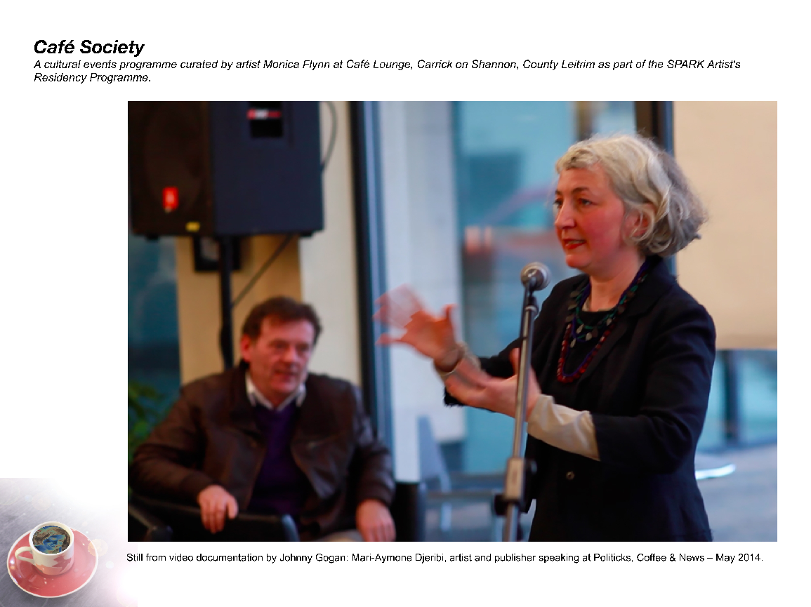

Café Society
a series of three public discussion events curated by artist Monica Flynn as part of Leitrim Co. Council’s SPARK residency. These events tapped into the history of Coffee Houses as places of culture and commerce, and the café as an enduring discursive public space.

at Café Lounge, Carrick-on-Shannon, Co. Leitrim

Fri. 2 May - Politicks Coffee and News with speakers Fiona Dowling, artist; Dr. Marie Kennedy, publishing historian and Mari-Aymone Djeribi artist-publisher. Looking at the history of cafés as part of the early public sphere and their connection with publishing.

Fri. 30 May - Café Philosophie with speakers Dr. Maeve Cooke, philosopher and social activist and convenor of Claiming our Future Niall Crowley, chaired by journalist Carole Coleman. Discussing the 'good society', ethics, values and citizenship.

Fri. 4 Jul - Cultural Capital with speakers Monica de Bath, artist and Finbarr Bradley educator and green economist. Examining cultural values in the broadest sense and grassroots approaches to civil protest and cultural and economic development.

Background to the project - excerpt from an interview with writer Joanne Laws

The history of cafés sparked a lot of ideas initially, particularly Parisian cafés, as public spaces where artists, writers and philosophers gathered. I was interested in the growing number of cafés around Ireland and how people are using them. The café struck me as a sort of in between space – neither work nor home – where commerce, publicness and cultural debate intersect. I wanted to harness notions of the Public Sphere and economics in a way that would appeal to the Café audience. The primary aim was to test the appetite for public debate, inviting speakers from academia, the media and the arts.

As artist-in-residence in a business setting, I was conscious of the rhetoric around 'creativity' which renders cultural production as economic commodity rather than something generated by the collective efforts of citizens. Pragmatically, I was concerned with ideas around active citizenship and the diminishing spaces for public debate. Philosophical reading material influenced my examination of cafés as discursive spaces, ‘heterotopic spaces’ and ‘spaces of potential’. I set up a small library in the Café, which included political and economic texts and other reading material that reflected my interests.

I wanted to use the first event to ‘set the scene’, while creating a sense of conviviality and a context for future events. I invited local artist-publisher Mari-Aymone Djeribi, publishing historian Dr Maire Kennedy and storyteller Fiona Dowling to contribute. Collectively they introduced cafés as part of an early Public Sphere, with an examination of their history in Europe and connections with publishing, commerce and literature. Maire discussed the history of cafés in Dublin, their role in commercial affairs and the early News Paper and publishing trade in Ireland. Fiona told a number of stories relating to the folklore of coffee in countries where coffee houses first became popular.

Focusing specifically on the Public Sphere, the second event ‘Café Philosophie’ was pivotal in the series. Dr. Maeve Cooke discussed Jürgen Habermas’ notions of ‘Communicative Freedom/Reason’, while Niall Crowley reflected on ways to counter modern-day Ireland’s 'low-energy democracy' by ‘Claiming our Future’ and reaching consensus on what kind of society we want. The event was chaired by Carole Coleman, who made interesting observations about her own profession, remarking on the media’s tendency to cover provocative political stories rather than asking critical questions. The audience got involved and there was genuine interest in the need for change, more robust debate in public life and a different kind of citizenship.

Discursivity emerged as an important aspect of this project. I feel that spaces for open discussion - to air and share ideas and social concerns, or act out alternatives - are very important. We create or find these kinds of spaces, but it's difficult to think of many spaces that function in this heterotopic sense. On the idea of congregating, there are many instances where we congregate in Ireland, including the pub, sports events, festivals and religious ceremonies. However, heterotopias function beyond that, as sites for action and speech that step outside of institutional or social norms, or where different relational norms can coexist and overlap. The café is a space where people come to take time out, to work, to meet others and can be open to striking up conversations with strangers. It is a privately owned yet public space. ‘Café Society’ tapped into the existing atmosphere and allowed discussions that would generally happen in institutional spaces to happen in this more relaxed setting. Over the last couple of years my work has employed different means of involving audience. Creating a discursive space seemed like a natural progression.

It took time to devise appropriate responses to the setting and its’ transient audience. It was hugely beneficial to engage with other artists and professionals from a variety of fields including history, publishing, media, philosophy, social activism and financial theory. In some ways, the open-ended nature of the discussions was a leap of faith, with the experience and response of the audience underpinning the effectiveness of the project.

I would now value the opportunity to bring this format elsewhere and into new contexts but mostly to maintain a relaxed open setting within which to engage a wide audience with meaty issues in an accessible way.’ Monica Flynn,

APPENDEX 4.

Community Context - LOCAL & NATIONAL DEVELOPMENT STRATEGIES

THIRD SPACE and its members are also members of local and national Professional Arts and Community Networks and aims to work in partnership with a number of local and national bodies including:

CREATE – National Development Agency for Collaborative Arts
Visual Arts Ireland – National Agency for Professional Visual Artists
ADAPT – Galway based Arts Network
GALCA – Galway based Community Arts network
GCCF - Galway City Community Network
CCAM - GMIT
CKI – NUIG The Community Knowledge Initiative (CKI) fosters community university partnerships that aim to promote the principles and practices of civic engagement and democracy. EPIC - Engaging People in Communities. EPIC works in close liaison with a wide range of individuals and groups, both inside and outside the university, to further civic links and partnerships, with particular emphasis on Community-Engaged Research and knowledge sharing and exchange

Creative Communities Report 2013
LOCAL GALWAY COMMUNITY ARTS DEVELOPMENT REPORT

In March and April 2013, Galway City Community Forum (GCCF), The Community Knowledge Initiative (CKI), National University of Ireland (NUI) Galway, and Galway Community Arts Network (GALCA) came together to organise two networking events entitled Creative Communities: People and Places, to bring together people who are active in or interested in Socially Engaged Arts/ Community Arts practices and projects in Galway, with the aim to provide a space to reflect on, map and facilitate discussion on current activities, strengths and requirements for promotion and development of creative communities and practices in this field in Galway City and County. Responses were recorded and the feedback report reflected the main concerns and issues, highlighting the need for a central space and further supports and educational opporutntiies in this field of practice… acting as a valuable and useful resource for policy development and for strategic planning of the promotion and development of community/socially engaged arts in Galway.

“The Organising groups also hoped that interested groups, organisations and individuals, along with Galway City Council and local agencies would take action on some of the requirements to support and promote the issues that are presented in the report.”

The Creative Communities Report 2013 - highlighted the critical need for information, both online and in print, for networking opportunities, for further research and for a wide range of training, education and professional development supports for community arts and social practice and
“recognised the need for increased advocacy and lobbying at local and national level to promote creativity and to embed the arts in community and in community education. The necessity of a central suitable resource space, providing information, resources and ways of linking communities and artists was seen as crucial.” Availability of appropriate funding, along with a wide range of other supports were identified as of vital importance in order to support existing and emerging artists who wish to engage with communities, building opportunity and working to ensure sustainability.

pdf of Creative Communities Report; 2013

file:///Users/martinafinn/Downloads/Creative%20Communities%20Report%20June%202013%20(1).pdf

NATIONAL ORGANISATION STRATEGIC DEVELOPMENT PLANS

BLUEDRUM “Community Culture”

A Five Year Strategy to Revalue, Renew, and Reinvent Community Arts, 2014
- is essentially a catalyst for change in the value accorded to CAP, the supports available to CAP, and the actual practice of CA in contexts of social exclusion.
It aims to build new understanding of CAP and its potential within communities experiencing disadvantage and inequality. It aims to support and develop new models of community arts that will involve an open tendering process for Lead projects and an annual programme of local community arts actions that will be funded in Cork, Limerick, Dublin and Galway over a five year period. It aims to develop the capacity of community arts to engage with the current urban disadvantaged context and to achieve tangible outcomes for communities of place, and to Engage organisations from a diverse range of sectors (child family youth and community organisations) in devising and advancing community arts practice and developing a local ecology for this practice. Devise and implement new directions for community arts practice in their community setting
Also aims to Provide a critical focal point for public discourse and learning about community arts practice and its potential.

FURTHER DEVELOP CAPACITIES FOR COMMUNITY ARTS PRACTICES:

An Annual programme of training events will be organised local and national
To include – A Common philosophy and pedagogy of practice; Process skills required for effective CA practice; Seek to develop strategic skills for Community Arts to engage more effectively with the current contexts for communities experiencing disadvantage and inequality and knowledge and understanding of the values and ethics in this field of practice.

BLUEDRUM aims to work with LOCAL PLATFORMS over the life of the strategy, Including Galway and these will be based on local structures to identify and develop further infrastructures to promote support and represent Community Arts practice in contexts of social exclusion.

Bluedrum aims to ACHIEVE a NEW VISIBILITY for and perspective on Community Arts practice and to develop a website and resource to inform and network all involved in Community Arts Practice.

Bluedrum “Community Culture” A five year strategy to revalue, renew, and reinvent community arts; 2014
http://issuu.com/bluedrum/docs/pamphlet_10_community_culture/1

NESF – The Arts, Cultural Inclusion and Social Cohesion: Report 35

Summary · January 2007 - looked at ways to encourage greater access to and participation in the arts by everybody. This report highlighted how taking part in the arts in Ireland indicated huge variations depending on your level of education, socio-economic status, the area in which you live, and your age etc.

Arts Council - Participatory Arts Policy

The Arts Council understands arts participation to include a broad range of practice where individuals or groups collaborate with skilled artists to make or interpret art. The practice involves a mutually beneficial two-way engagement that nurtures and values the different ideas, experiences and skills of all involved. Arts participation is a core value across all areas of the Arts Council's work, as we are committed to increasing public access, participation and engagement in the arts.

The current strategic context for the Arts Council’s support of arts participation and all other artforms and areas of arts practice is set out in the Arts Council Strategic Statement 2013 (PDF, 0.46 MB). There the Arts Council gives an overview of its work and indicates the guiding principles that inform its actions and decisions. These are taken to realise the four goals and achieve the twelve objectives set out in that document.

What is the Relationship between Art and the Economy? ‘ For Every 1 Euro invested in the Arts in Ireland, 2 Euros are gained” – The Social Economic and Fiscal Status of Visual Artists in Ireland 2009; Visual Artists Ireland

“Some E76 million of Arts Council funding to organizations in Ireland supports more that 3000 jobs, generates E192 million in turnover, and E54 million of it returns directly to the exchequer in taxes, the report found” - Deirdre Falvey, The Irish Times November 5th 2009

Cultural Tourism“ Cultural Tourism contributes E5.1 billion to the Irish Economy and represents the only part of the tourism sector that has seen growth in recent times” - Western Development Commission, Creative West

“ The more successful a region is at generating a creative infrastructure that connects pure arts to education to commercial businesses to tourism, the more successful it will become. The West of Ireland, to pursue thie one example, is not at the moment translating its magnetic cultural image into the creation of such a region” – Fintan O’Toole, The Irish Times March 28th 2010.

“Culture’s role in tourism is key. Tourism offers are now increasingly focused on what is unique in a place and ‘cultural tourism’ represents an average of 6% to 8% of nations’ GDP in Europe. Cultural Tourism gives visitors the opportunity to understand and appreciate the essential character of a place and its culture as a whole, so a good cultural tourism strategy can also satisfy the requirements of sustainable economic development. Back in 2002, the World Tourism Organisation, established that 37th % of all tourism (265 million international trips ) was cultural in nature and this trend was set to grow at a remarkable 15% per annum. According to the European Commission, 45- 50% of tourist motivations in the world’s largest single market are ‘cultural’ in nature and origin” - A Cultural Quarter for Sligo, 2005

APPENDEX 5. THIRD SPACE ACTIVITES AND EVENTS 2014

Third Space Galway established an experimental context, both on and off line, to animate interdisciplinary critical discourse, cultural research and activity by offering a thought-provoking programme of transdisciplinary collaborations, discursive events, film screenings.

1. Third Space hosts every fortnight an INTERDISCIPLINARY RESEARCH FORUM with the generous support of CKI (Community Knowledge Initiative), NUIG.
Our last meeting took place on Tuesday 2nd December, 2.30 -4.30pm in the Community Knowledge Initiative Office, Corrib Village, NUI Galway, Dangan

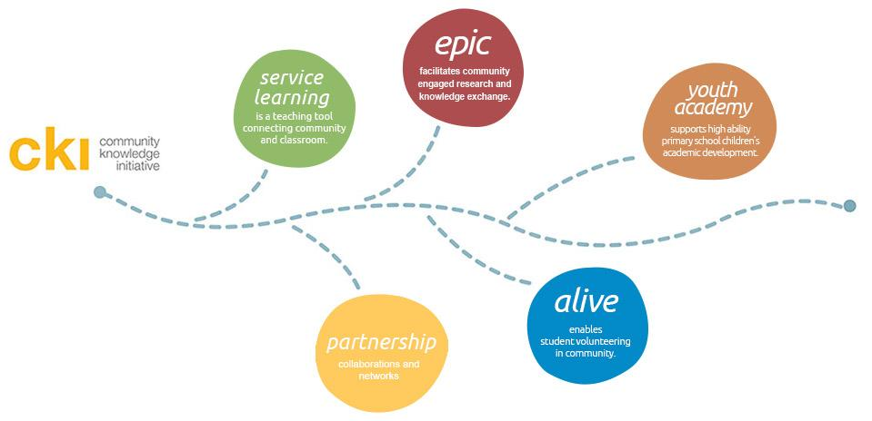

For Discussion please see below a link to the recent Fire Station Artist Studios seminar that took place on 13th Nov. 2014 ‘The intersection between Art and Politics”, with contributors –
- Ana Dević (WHW Croatian curatorial collective)
- Megan Johnston (Curator & Director of The Model Art Centre)
- Jesse Jones (Artist). Chaired by Liz Burns (Fire Station Artists’ Studios)
http://soundcloud.com/fire-station-studios/megan-johnston?in=fire-station-studios/sets/the-intersection-of-art-politics
And also a text by John Molloy “Wild Country: Art, Community and the Rural, commissioned by Bluedrum in 2009″
http://www.bluedrum.ie/documents/Blueprint1JohnMulloy.pdf

This event open to the public and everyone is welcome.
Directions:
Community Knowledge Initiative Office Building in Corrib Village, NUI Daingean before Daingean Nurseries – on the right, on the road to Moycullen.
Please contact 0872201972 for further information

2. Exploring the intersection of art and social and political change.
Friday 14 November 1.30-5.35pm

THIRD SPACE HOSTS A LIVE STREAM of CREATIVE TIME SUMMIT 2014
plus LOCAL DISCUSSIONS
Hardiman Research Building, NUI Galway

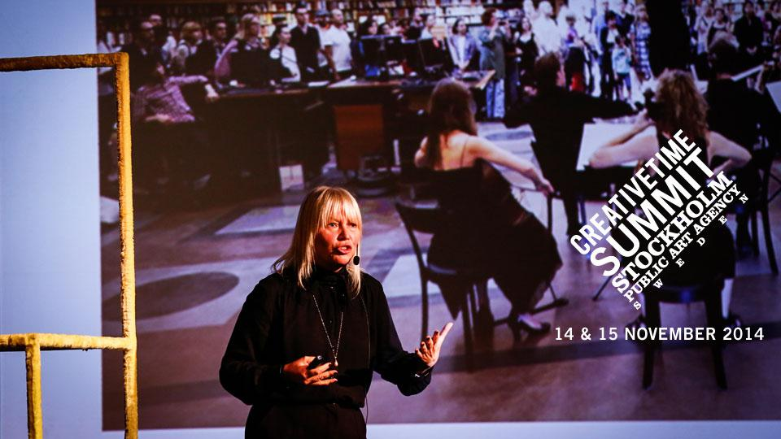

This year’s summit focuses on expanded public practice, investigating uses and potentialities of art in the public sphere, with a focus on practices with social and political implications. The Summit wishes to discuss the role that artists can play in producing more equitable and thoughtful responses to current day crisis and conditions and how these challenges are met by artists through re-imagining the public realm.

The 2014 Creative Time Summit this year takes place in Stockholm and asks.. ‘Who is art in the public sphere for and what is it supposed to do? How does art produce debate, contribute to a sense of the civic, or perhaps, more cynically, merely perpetuate the status quo?
Summit Stockholm will bring together artists who perform new interpretations of the city, reclaiming and reformulating the ways we interact and experience each other and the built environment.

Stop by during the afternoon to the Hardiman Research Building and learn more about new developments and the cultural practitioners and thinkers to the fore in this field of practice and be part of the global dialogue on some of the most pressing issues of our time.

1:30- 3.05PM: PERFORMING THE CITY – LIVE STREAM
The city operates not just as backdrop to public art but also as inspiration and a site and stage for opposition. While some artists enjoy what is possible in the city, others produce new lenses to understand its possibilities. The relation between artist and city is often performative–and like the city, these expressions range from grandiose to quietly intimate.
Andrea Phillips (moderator), Myriam Lefkowitz, Nástio Mosquito, Núria Güell, Poste Restante, Jeremy Deller in conversation with Nato Thompson

3:05- 3.45 PM – LOCAL DISCUSSIONS

Research Paper by Local Galway City Architect, Rosie Webb, titled – The Governmental Lab, an outline of her current project in Woodquay, Galway City – Designing with Communities and discussion with Bernadette Divilly who presents on her project Walking Wisdom Woodquay part of the city’s participatory design process

3.45-4.00pm Coffee Break

4:00- 5.25PM: ACTIVATING PUBLIC SPACE- LIVE STREAM
Public art today includes projects that strive to activate the civic beyond the level of aesthetics. These artists deploy forms of engagement that enliven and contest what is possible in the commons. These practices offer an alternative to formal modes of art production and a new sense of the role of culture in the composition of the urban landscape.
- Magdalena Malm (moderator), Nina Möntmann, Roberta Uno, Joanna Warsza, Maria Lind, Tensta Konsthall, Bettina Pehrsson, Marabouparken, Work Group Representing Konsthall C, Miriam Andersson Blecher, Botkyrka Konsthall

5.25- 5:30PM CLOSING REMARKS Nato Thompson
Learn more about the summit here:
http://creativetime.org/summit/overview/overview-2014/

Creative Time is a New York based public art agency committed to supporting socially and politically engaged art. Now in its sixth year, the annual Creative Time Summit is a key conference globally, exploring the diverse ways in which artists are tackling social and political issues, platforming voices from arts and activism and highlighting diverse strategies for social change. This year the summit is convening in Europe for the first time. Creative Time have partnered with Public Art Agency Sweden to co-develop a packed two day programme. Summit: Stockholm will focus on innovative practices that relate to five core themes: Nationalisms, Performing the City, Activating Public Space, Art in the Age of Surveillance, and Migrations. www.creativetime.org

This year’s summit includes• keynote addresses from: Edi Rama (Prime Minister of Albania) and Saskia Sassen (Professor of Sociology at Columbia University). and Live streamed presentations from leading artists, activists, curators and critics from around the world including: Tania Bruguera, Jeremy Deller, Maria Lind, Amar Kanwar and Joanna Warza. Dora Garcia, Tone Olaf Nielson, Nastio Mosquito

3. - Third Space Members submit TULCA proposal Comín to take part in a series of public interventions in response to the Tulca Curator Aisling Prioir’s Open Call – unsuccessful August/ September
________________________________________________________________

4. Third Space members attend:
July 18th 2014 – The Workers Symposium – Roscommon Arts Centre
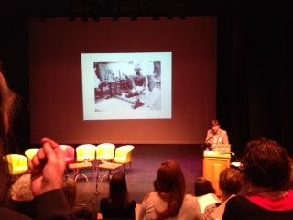Guest Contributors included; Grizedale Arts (UK) Fiona Woods (Visual Artist, IE ) & Richard Saxton (Co- Director of M12, USA)
Deirdre O’Mahony (VIsual Artist, IE) Philip Delamere ( Leitrim Arts Officer, IE)
MICHELLE BROWNE, GARETH KENNEDY, ELAINE REYNOLDS (EXHIBITING ARTISTS, THE WORKERS EXHIBITION, ROSCOMMON ARTS CENTRE GALLERY)
HOLLIE KEARNS & ROSIE LYNCH (INDEPENDENT CURATORS/WORKHOUSE ASSEMBLY, IE)
CHAIR: KATHERINE ATKINSON, CREATE
Photo: Adam Sutherland – Grizedale Arts, Honesty Shop Coniston Institute

5. June 2014 – Third Space Arts Research Collective visit EVA – Agitationism

In the past few years we have witnessed protests unfolding into serious unrest across many parts of the world. After initial excitement at this new global wave of voicing political demands, seasons change, and what was a novelty becomes a norm that lures many of us into the trap of trying to determine and define this previously undetermined phenomenon. Such engagements with current political upheavals can be termed agitations, an old philosophical term which denotes the extreme tension of the brain in its attempt to determine something perceived as previously undetermined—such as a sublime experience of nature. These agitations usually recast the sense of the human self accompanying all thinking into a clearly distinguishable entity, treating it as if it were something we could claim to really understand.

Agitationism, on the one hand, is the condition of living under a constant flow of agitations, including the ones that you inevitably sometimes produce yourself. However, it is also the process of ‘working through’ them with the aim of seeking adaptation to a logic situated somewhere else beyond the entrapment between past, present, and future—three tenses that overlap in the contemporary moment, creating a kind of palimpsest of half undone histories, half imagined futures, and a present of phantasms as a consequence.
EVA International 2014 AGITATIONISM simulates the sense of living under agitation while capturing how we are slowly adapting to a different perception of the world by working through our relationships with historical ideologies, post-colonial narratives, other beings (including animals), and speculations about the not-so-distant future.

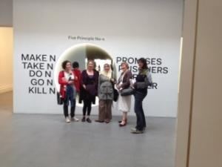
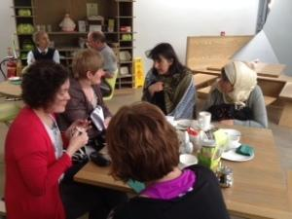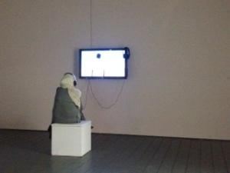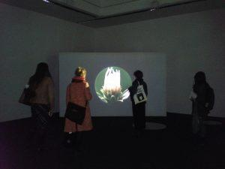

6. May 15th 2014 – ! WAR – ! Women Art Revolution Film Screening
Main Room, Huston School, NUI Galway. 7:00 pm

Third Space Arts Research Collective in partnership with The Huston School, NUIG & VAI assistance – screens Lynn Hershman Leeson’s film !Women Art Revolution

For over forty years, Director Lynn Hershman Leeson has collected hundreds of hours of interviews with visionary artists, historians, curators and critics who shaped the beliefs and values of the Feminist art and which reveals previously undocumented strategies used to politicize female artists and integrate women into art structures.

New ways of thinking about the complexities of gender, race, class, and sexuality have evolved. The Guerrilla Girls emerged as the conscience of the art world and held academic institutions, galleries, and museums accountable for discrimination practices. Over time, the tenacity and courage of these pioneering women artists resulted in what many historians now feel is the most significant art movement of the late 20th century.

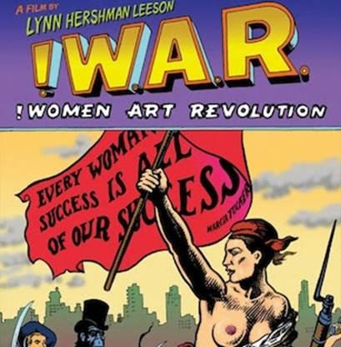
http://www.womenartrevolution.com/

7. April 7th 2014 – 126 Artist led Gallery, Galway

Socially Engaged Artist, Ceara Conway invited THIRD SPACE Arts Research Collective to participate in the discursive aspect of her socially engaged art project, Making Visible – that aimed to highlight and Make Visible the current Direct Provision system in Ireland and to bring to light the suffering of Asylum Seekers living within this system. As part of Making Visible, Ceara held a week long series of discussions in 126 gallery and invited Third Space to participate –
Dr. Rebecca Breen and Dr. Aine Phillips in ‘The Role of Testimony in Art’

Drawing upon the old Irish tradition of “Caoineadh”, a vocal lament associated with mourning, Ceara created a series of ritual performances that were informed by her time engaging with “Able Women”, a group of women who are currently seeking asylum and living in Galway. In the series of performances each woman had chosen a lament from their own country and a location in Galway City where they wished to have it performed. The location and lament they had chosen was pertinent to a personal aspect of their experiences living within the direct provision service in Galway. Following these off site performances in the City, Ceara held a 2 week Vigil and discursive event in 126. For more information – please visit Ceara Conway Making Visible

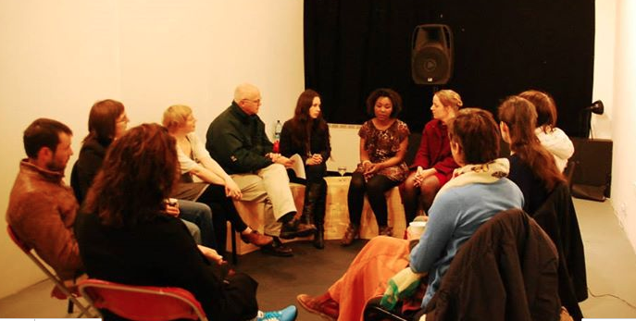

8. THIRD SPACE ATTENDS: March 25th 2014
– Public Talk by Bassam El Baroni – EVA Curator 2014
Seminar in An Taidhbearc, Galway

Bassam El Baroni is a curator and writer based in Alexandria, Egypt. He is the Curator of EVA International 2014 edition “Agitationism” which took place from 12 April – 6 July in Limerick City.

El Baroni co-founded Alexandria’s first non-profit art space, Alexandria Contemporary Arts Forum (ACAF) in 2005 working with International and Egyptian Artists on a wide variety of projects until the space’s closure in 2012. His work aims to be reflective of a positioning that is neither an argument for arts autonomy nor a demand for a socio-politically engaged art in the prevalent sense of the term, but rather a search for the maximisation of art’s critical and political potentials.
El Baroni currently teaches theory at the Dutch Art Institute, Arnhem, the Netherlands and is a PhD researcher at the Curatorial/Knowledge programme, Goldsmiths, University of London. He was co-curator of Manifesta 8, The European Biennial of Contemporary Art, 2010, Murcia, Spain, for which he curated (with Jeremy Beaudry, ACAF’s former associate curator) OVERSCORE, an exhibition project in three different venues. He recently co-curated (with Anne Szefer Karlsen and Eva González-Sancho) the Lofoten International Art Festival (LIAF), Norway, 2013; and curated When it Stops Dripping from the Ceiling (An Exhibition That Thinks about Edification), 2012, at Kadist Art Foundation, Paris.
Hosted as part of the 2014 programme entitled “The Para- Institution” curated by Galway city Curator in Residence Megs Morley

9. THIRD SPACE INVITED TO ATTEND - 12th February 2014
National Campaign For the Arts COLLOQUY #4 – Radisson Hotel, Galway

Education and the Arts: Policy, Research and Responsibilities

This colloquy addressed the fundamental question of education, arts policy and research in the development of arts participants, audiences and practitioners in the future. The event featured three speakers: Ms. Hannele Lehto (Finland), Dr. Julian Sefton-Green (UK) and a local respondent.
The aim of the NCFA Colloquia series is to amplify and illuminate key research issues for the arts and arts policy in Ireland. Specifically, to develop a research agenda for the arts/arts policy and to increase understanding and debate about the arts in Ireland and to do this by bringing together key stakeholders in the delivery, reception and policy context of the arts – the public (civil society/public sphere etc.), arts practitioners and the government (including policy makers etc.). This was the final of four core events in the NCFA Colloquia series curated by Tara Byrne, independent arts manager and cultural policy adviser.

"I believe that an artistʼs relationship to and placement in society should not be an area of specialization, or afterthought, but instead a core component of the education of all artists... the education of future generations of artists could place significant focus on social implications... they should be thinking about context, publics, and social function. This should be the basis of all art education today." Jen Delos Reyes, Open Engagement, US

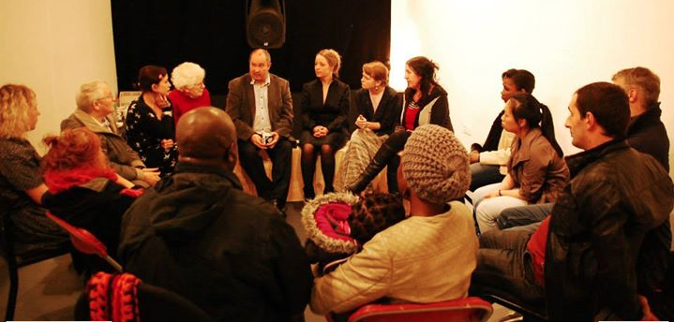
Ceara Conway Discursive Event as part of Making Visible April 2014

A Blade of Grass - http://www.abladeofgrass.org/growing-dialogue/growing-dialogue-the-latest-thing-8/ Field - http://field-journal.com/sample-page

